An Approximate Gazetteer for GATE based on Levenshtein Distance
Bruno Woltzenlogel Paleo1

1 Technische Universität Dresden, Fachschaft Informatik,
01307 Dresden, Germany
bruno.wp@gmail.com
Abstract. GATE is an architecture that allows the use and development of useful plugins for typical Natural Language Processing tasks. However, there is currently no plugin capable of annotating a document that contains words that only approximately match words specified in a list of words to be searched. Here we describe the development of such a plugin, based on Levenshtein Edit Distance, and its integration to the GATE environment. This plugin enables GATE to be useful for tasks in which exact matching is not enough.
Keywords: Natural Language Processing, Edit Distance, Levenshtein Distance, Aprroximate String Matching.
1 Introduction
GATE (General Architecture for Text Engineering) provides a simple abstraction of a typical Natural Language Processing task. In this abstraction, each task is defined as a pipeline, consecutively applying different processing resources (Part-of-Speech taggers, Sentence Splitters, Gazetteers, …) to a given language resource (a text document or a collection of text documents). The output is a language resource enriched with annotations.
Here we are interested in a particular type of processing resource called Gazetteer. In section 2 we explain what is the purpose of a gazetteer, what annotations it produces and how the DefaultGazetteer provided by GATE works.
In Section 3 we briefly describe a few applications in which the DefaultGazetteer is not useful, because it is not able to cope with noise or errors in the language resource. These applications are the motivation for the implementation of a new gazetteer, here called BWPGazetteer. Section 4 describes its ideas and algorithms and Section 5 shows details of its implementation according to the GATE framework and its integration to the GATE GUI. Finally, in Section 6, we evaluate this new gazetteer.
2 Gazetteers
Gazetteers search for words in texts. Whenever one word belonging to one of the gazetteer’s lists of words is found in the text, the matching region in the text is annotated with the majorType and minorType associated with the list to which the word belongs. If, for example, one of the lists of the gazetteer is a list of city names, then for each matching city name encountered in the text, the gazetteer will produce an annotation with the following parameters:
- Start – the position where the matching word starts.
- End – the position where the matching word ends.
- Features – a set of features associated with the annotation (for the city example, it would be {majorType=location, minorType=city})
- Lookup – the set of annotations to which this annotation belongs.
  - GATE’s DefaultGazetteer
Gate provides, within its plugin ANNIE (A Nearly New Information Extraction System), the interface Gazetteer and the class AbstractGazetteer, which specify the minimal requirements of a gazetteer in terms of properties and methods that they should have and implement the basically functionality of some methods. Additionaly it provides the class DefaultGazetter, extending AbstractGazetteer and implementing Gazetteer into a fully functional gazetteer.
DefaultGazetteer is based on finite state machines (FSM). When it is loaded, all the words in its lists are read and a FSM is built combining all of them so that their characters are the labels in the transitions between the states, and a state is final whenever it corresponds to the end of a word. When the DefaultGazetteer is executed on a text, it reads the characters of the text and performs the corresponding transitions in the FSM, adding annotations when it finds final states.
The lists of words to be searched and annotated are simple plaintext files with one word in each line, and the gazetteer becomes aware of these lists by reading another file (“lists.def”), in which each line points to a different a list that should be used and specify its majorType and minorType features. An example of “lists.def” might look like:

city.lst:location:city
country.lst:location:country

In this case, the gazetteer will search all words specified in the plain-text files “city.lst” and “country.lst” and will annotate the occurrences found with the features {majorType=location, minorType=city} for words in “city.lst” and {majorType=location, minorType=country} for words in “country.lst”.
3 Applications of Approximate String Matching
Although the DefaultGazetteer, based on FSM as described previously, is very efficient and has a good precision, its recall may be not so good for some applications, because it is only able to detect exact matches of the words. If one character is mistyped in the name of a city in the text, for example, this occurrence will not be found. The application areas briefly described below are examples that require a more flexible Gazetteer, capable of detecting occurrences with noise and errors:

- Bioinformatics – one of its common tasks is to align sequences of DNA or Aminoacids in genes or proteins. These sequences can be seen as texts and since genes and proteins may contain mutations and abnormalities, approximate (inexact) matching is necessary for the alignment.
- Information Retrieval – if the documents that are being analyzed contain errors and noise, the demanded document might not be found simply because the relevant word contained errors and hence it couldn’t be found by exact matching. Noise and errors in documents can come from digitalization via Optical Character Recognition (OCR) or from Speech recognition technologies.
- Text Classification – Text classification based on the annotations of a gazetteer may have their accuracy hindered if the gazetteer does not find noisy occurrences of the relevant words.
- Multi-language search – Some languages are similar in their vocabulary, having words with the same root but with slightly different derivational morphology (e.g. “Algeria, Algérie”, “Andorra, Andorre”, “Bhoutan, Bhutan, Butao”). Different morphology may also occur as a result of internet slang. A gazetteer with approximate matching would be able to recall all these words, without knowledge of the morphology particularities of each language.
- Text Correction and Completion – A system might suggest corrections and completions for a word that has matched only approximately some word in the list of words. This may be useful and feasible for applications with a limited vocabulary.
- Recovering from Noise in Signal Analysis – By finding the best match for a noisy signal according to an allowed code, it is possible to recover the intended message.

By programming a simple approximate gazetteer, here called BWPGazetteer, we expect to expand the frontiers of application of GATE to all these areas. We also note that an improved recall provided by an approximate gazetteer may also benefit already classical areas of application of GATE, since other types of processing resources usually use the results of gazetteers. Sentence-splitters, for example, would benefit from a better detection of abbreviations by a gazetteer.

4 The Classic Levenshtein Distance and some Improvements
To determine whether a string approximately matches another string, we need a distance function to measure how distant from each other the two strings are. There are different such functions [2]. For the BWPGazetteer, we chose the Levenshtein distance [1], because it seems to be a good compromise between flexibility to deal with different kinds of errors and efficiency of the algorithms that compute it.
The levenshtein distance between two strings is defined as the minimum number of operations to transform one string into the other, where the operations may be deletion of a character, insertion of a character or substitution of a character. Thus the distance between “aaa” and “aaaa” is 1, because one ‘a’ must be inserted in the first string to make it equal to the second string. Analogously, the distance between “aba” and “aca” is also 1, because ‘b’ must be substituted by ‘c’. Additionaly, the different operations may have costs that are different from 1 and the cost may even depend on the characters that are inserted, deleted or substituted. This allows us to particularize the distance to specific types of errors and noise.
To compute the minimum distance, a dynamic programming algorithm can be used. We incrementally fill a bi-dimensional array D, where D[i][j] stores the distance between the initial prefix subtrings of length i and j respectively of the first and second string. Clearly, to compute D[i][j], we just need to take D[i-1][j-1], if the characters in position i of the first string and in position j of the second string are equal, or we need to take the minimum of {D[i-1][j-1]+substitutionCost , D[i][j-1]+insertionCost, D[i-1][j]+deletionCost}. Thus we can fill the array from left to right and from top to bottom, since in this way we guarantee that we always have previously calculated the values that we need to calculate D[i][j]. Once the array is finished, we can read the final distance between the two strings in its bottom-right corner. If this distance is below a fixed threshold, we may be willing to consider both strings to match each other. Table 1 shows an example of such a computation.

Table 1. Example of computation of Levenshtein distance between the strings “CATO” and “GATE”.
 |  | C | A | T | O
 | 0 | 1 | 2 | 3 | 4
G | 1 | 1 | 2 | 3 | 4
A | 2 | 2 | 1 | 2 | 3
T | 3 | 3 | 2 | 1 | 2
E | 4 | 4 | 3 | 2 | 2

This algorithm is O(n.m) both in time and space, where n and m are the lengths of the strings.
4.1 Finding Several Matches in a Text
The algorithm presented previously decides whether 2 strings match, but it’s not able to decide whether 1 of the strings matches a substring of the other string (which may be a much longer string, containing a whole text full of words and sentences). Neither it is able to find the positions where these matches occur.
A very naïve approach to solve this problem would be to compute the distance of the string to each possible substring of the text. However, this would be too slow, because a text of length m would have 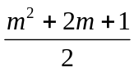 possible substrings. A slightly less naïve approach would be to consider only some of these substring, only those separated by spaces and presumed to be words, for example. But with this approach, we cannot handle errors related to insertion of spaces in the middle of words or removal of spaces between words.
Fortunately there is another solution which is as computationally expensive as solving the problem of simply computing the levenshtein distance between two strings [2]. Let’s assume that the text (the bigger string) is horizontal in the distances array (i.e. the array has as many columns as characters in the text plus one). Then by initializing the first row of the array with zeros, we implicitly tell the algorithm that the matching of the string may start at any position in the text. And then we can detect the matches by looking at the last row and seeing which cells contain values that are below the distance threshold.

Table 2. Example of detecting matches (in orange) in a text with the dynamic programming algorithm. Searching for “CA” in “CATACA” with distance threshold equal to 0.
 |  | C | A | T | A | C | A
 | 0 | 0 | 0 | 0 | 0 | 0 | 0
C | 1 | 0 | 1 | 1 | 1 | 0 | 1
A | 2 | 1 | 0 | 2 | 1 | 1 | 0

However this solution (as described in [2]) only finds the end position of a match. To determine its start position, we may compute for each cell of the array not only the distance but also the number of deletions and insertions that were used to yield that distance. And then we can find the start position according to equation 1:
startposition = endposition – (length_of_string + #insertions - #deletions) . | ()

For example, searching for the word “York” in the text “New York” with distance threshold equal to 1, will first give us two matches, one of them with endposition in the 7th character and 1 deletion operation and the other one in the 8th character with 0 deletion operations. Then we compute the startposition for both of them and the result is the 5th character.

This algorithm, although sound, is still incomplete. It didn’t find the matching of “York” with the substring “ork” in the text, which requires only 1 deletion of the character ‘Y’. In order to fix this and obtain a complete algorithm, all we have to do is to consider more matches (and add the corresponding annotations), with increasing values of startposition, until the distance threshold is not satisfied anymore. For the above example, after we computed the startposition to be the 5th character for the match of “York” with “York” with distance 0, we consider increasing the startposition to the 6th character. This corresponds to the deletion of a character and thus the distance of this candidate match would be 1. Since this distance is below the threshold, we annotate this match. Then we consider increasing the startposition to the 7th character. This corresponds to 2 deletions and thus to a distance of 2, which is above the threshold. Therefore we don’t annotate this candidate match and we stop increasing the startposition.
4.2 Avoiding Overlapping Matches
The procedure described above generates several overlapping matches (and their corresponding annotations) on an occurrence of the word, each match with different degree of error within the distance threshold. In most applications, these overlapping annotations are not desirable. The algorithm should return only the best (minimum distance) of such overlapping matches.

To find only the endposition of the best matches, it suffices to analyze the last row of the table, considering the sequences in which the distance is below the threshold. For these sequences, the best (non-overlapping) matches are only those that are local minima of distance. Table 3 illustrates the avoidance of overlapping matches.
Table 3. Avoiding overlapping matches with a distance threshold of 2. Normally, we would obtain 4 matches (shown in yellow), but in order to avoid overlapping, our algorithm may return only those corresponding to local minima (shown in red) in the sequences of matches.
 |  | T | C | A | T | G | G
 | 0 | 0 | 0 | 0 | 0 | 0 | 0
C | 1 | 1 | 0 | 1 | 1 | 1 | 1
A | 2 | 2 | 1 | 0 | 1 | 2 | 2
T | 3 | 2 | 2 | 1 | 0 | 1 | 2
T | 4 | 3 | 3 | 2 | 1 | 1 | 2

Since, in general, an application may need the overlapping annotations, our implementation allows the user to choose whether he wants to avoid them or not.
4.3 Saving Memory Space
For very long texts, the size of the distance array can be quite big. And it doesn’t need to be, if we note that to compute a column, we just need the previous column. Hence, the memory use of the algorithm may be reduced from O(n.m) to O(n). The time continues to be O(n.m).
4.4 Normalization of Distances
Since the size of strings vary, it is not very convenient to deal with absolute distances. One character mismatch in a short word is much more relevant than one character mismatch in a long word. Hence our BWPGazetteer deals instead with relative distances. The relative distance threshold is specified in a range from 0.0 to 1.0 and then for each word that is searched, an absolute distance threshold is computed by multiplying the relative threshold by the length of the string. Then the algorithm is applied normally with this absolute distance threshold.

5 Integration of BWPGazetteer to GATE
The documentation of GATE is not very easy to understand, specially when it comes to integrating our own code to the graphical interface. It also seems to be a little outdated, because GATE sometimes behaved differently from what was specified in the user manual. Hence it was a long time until the BWPGazetteer could finally work within GATE. What should be done, though is quite easy, after one knows what it is.
5.1 Interfaces and Abstract Classes
The first step was to understand what classes should be used and what interfaces should be implemented. This was a little confusing, because although the DefaultGazetteer is part of ANNIE, the classes were not in the ANNIE package but actually in the gate.creole.gazetteer package.
BWPGazetteer is a subclass of AbstractGazetteer implementing the Gazetteer interface. As such, it has the following methods:
- init( ) – called when BWPGazetteer is loaded in the GATE GUI. It basically reads the files containing the words that have to be searched and store these words and their corresponding annotation “lookups” in vectors.
- execute() – called when a pipeline in the GATE GUI containing BWPGazetteer is run. For each word in the vector of words, it executes the dynamic programming algorithm to annotate occurrences of that word.
5.2 Packaging the Component
After BWPGazetteer component was finished, it had to be built and packaged in a “.jar” file, which will then be accessed by GATE when creating and using instances of the component in the GUI.

5.3 CReOLE
CReOLE (Collection of Reusable Objects for Language Engineering) is the collection of language resources and processing resources conforming to the interfaces and to the framework of GATE and integrated in it. For a component to be integrated into CReOLE, a configuration file (“creole.xml”) must be provided, which tells GATE’s CReOLE Plugin Manager how to deal with the component. BWPGazetteer’s configuration file is shown below:

<CREOLE-DIRECTORY>
<CREOLE>
<RESOURCE>
<NAME>BWPGazetteer</NAME>
<JAR>BWPGazetteer.jar</JAR>
<CLASS>bwp.gate.gazetteer.BWPGazetteer</CLASS>
<COMMENT>A BWPGazetteer.</COMMENT>
<PARAMETER NAME="document" RUNTIME="true"
COMMENT="The document to be processed"> gate.Document</PARAMETER>
<PARAMETER NAME="annotationSetName" RUNTIME="true"
COMMENT="The annotation set to be used for the generated annotations"
OPTIONAL="true">java.lang.String</PARAMETER>
<PARAMETER NAME="listsURL"
DEFAULT="lists.def"
COMMENT="The URL to the file with list of lists" SUFFIXES="def">
java.net.URL</PARAMETER>
<PARAMETER DEFAULT="UTF-8"
COMMENT="The encoding used for reading the definitions" NAME="encoding">
java.lang.String</PARAMETER>
<PARAMETER DEFAULT="true"
COMMENT="Should this gazetteer diferentiate on case"
NAME="caseSensitive">java.lang.Boolean</PARAMETER>
<PARAMETER DEFAULT="true"
COMMENT="Should this gazetteer only match whole words"
NAME="wholeWordsOnly">java.lang.Boolean</PARAMETER>
<PARAMETER DEFAULT="0.15" COMMENT="Maximum normalized (0.0 - 1.0) distance for a match” NAME="normalizedDistanceThreshold">java.lang.Double </PARAMETER>
<PARAMETER DEFAULT="true"
COMMENT="Should this gazetter avoid overlapping annotations"
NAME= "avoidOverlapingAnnotations">java.lang.Boolean</PARAMETER>
</RESOURCE>
</CREOLE>

</CREOLE-DIRECTORY>

The meaning of “creole.xml” is not hard to see. It specifies the name of the resource and the “.jar” file where it can be found. And then it lists parameters that have to be set by the GATE GUI when a new instance of the resource is created. The most important parameters are “listsURL”, which points to the “lists.def” file containing pointers to the lists of words that should be used by the gazetteer; the “normalizedDistanceThreshold”, which specifies the maximum distance for a match to be considered; and “avoidOverlapingAnnotations”, which informs the Gazetteer whether it has to search for overlapping matches. Each parameter is a private variable of the specified type in the java class. Getter and Setter methods with appropriate names must be provided by the class, so that the GUI can manipulate these variables.

5.4 Integration and Use
With both the “.jar” file and the “creole.xml” configuration file finished, we can proceed to GATE’s CReOLE PlugIn Manager. According to figure 1, we first click in “Add a new CReOLE repository” and provide the folder which contains BWPGazetteer’s “creole.xml” file. BWPGazetteer will then appear in the list of known CReOLE directories, where it can be selected and loaded.

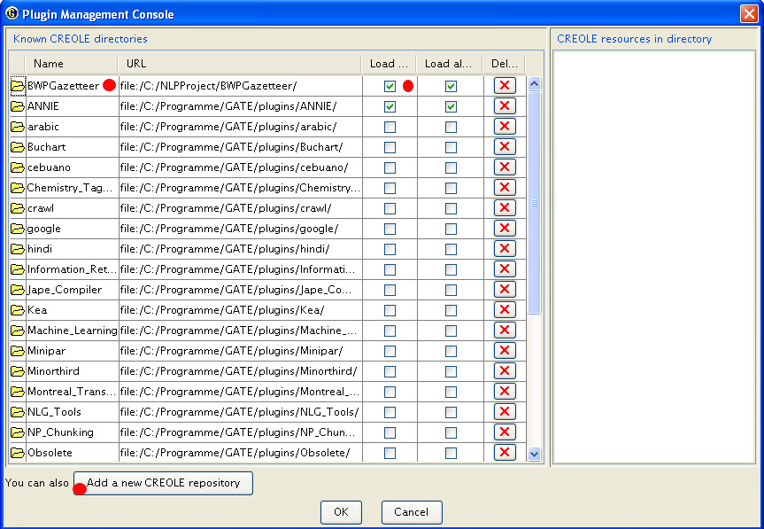
Fig. 1. Adding BWPGazetteer to GATE using the CReOLE PlugIn Manager.
After it is loaded, a new instance of BWPGazetter can be created by clicking in the processing resources and choosing it from a list, as shown in figure 2.

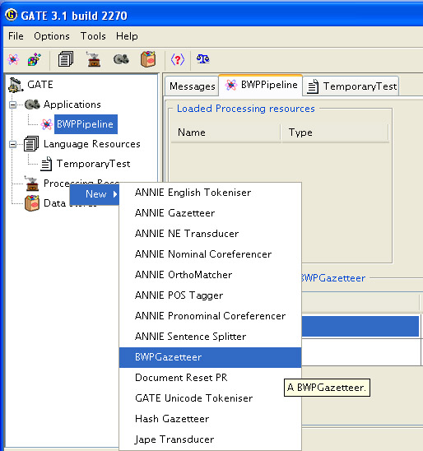
Fig. 2. Creating an instance of BWPGazetteer.
Finally, GATE will display a window where the parameters of the Gazetteer may be set, as shown in figure 3. And then the created instance may be added to a pipeline, where it is specified which language resource should be processed by the gazetteer.

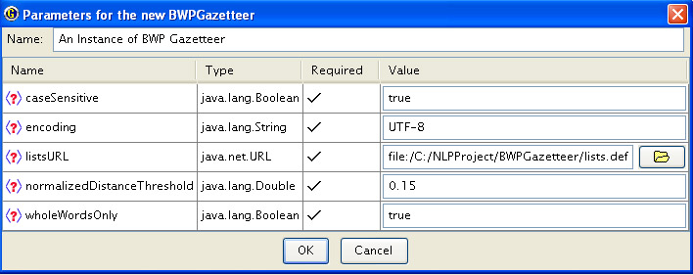
Fig. 3. Setting those parameters of BWPGazetteer that were specified in “creole.xml”.

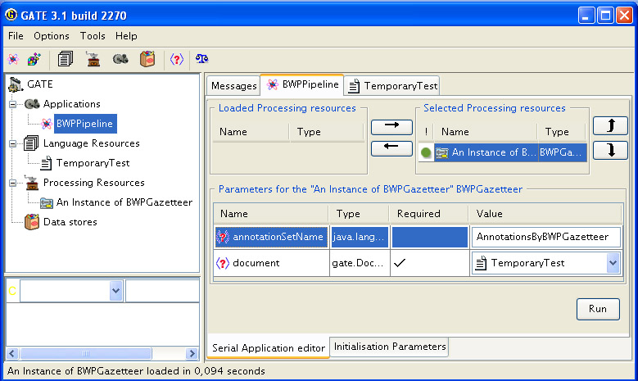
Fig. 4. Adding BWPGazetteer to a Pipeline to process the language resource “TemporaryTest”.

6 Evaluation of the BWPGazetteer
To evaluate our algorithm, we were primarily concerned with its time performance and its accuracy, in comparison with GATE’s DefaultGazetteer.

6.1 Time Performance
Since GATE does not display the time needed to run the algorithms, it was not possible to do a quantitative comparison of both algorithms with respect to the time used to process a language resource. Qualitatively, it is very clear that BWPGazetteer is much slower than DefaultGazetteer, though. While BWPGazetteer has to scan the text once for each word that is searched for, DefaultGazetteer compresses all words in a FSM and thus is able to search for all of them simultaneously.
This linearity of BWPGazetteer’s time performance with respect to the number of words that are searched for, constitutes its main disadvantage and restricts its practical usage to small lists of words. This was the price to pay for its extra functionality.
6.2 Accuracy
An interesting way to statistically evaluate the accuracy of BWPGazetteer would be to measure its recall and precision for a large annotated corpus of noisy text. After searching for such a corpus in the InterNet and discussing with the developers of GATE, we discovered that the Linguistic Data Consortium (LDC - http://www.ldc.upenn.edu/) has an ACE annotated corpus of degraded texts and ACE annotations could be easily transformed to GATE annotations. However, LDC language resources are accessible only for members and membership costs vary from US$1000 to US$25000 per year.
Another possibility would be to create our own annotated corpus of noisy text, possibly obtained via OCR. This would be too time-consuming. Therefore it was not pursued.
Finally we decided to evaluate our algorithm only qualitatively, in order to find possible directions for future works and improvements.

As language resource to be processed, we used a single XML file (“data.xml”) containing several names of cities and their geographical coordinates. This data is used as input for a simple GoogleMap javascript located in [http://planeta.terra.com.br/arte/lua/ , section “Trips > Map of Trips”]. A short part of the file can be seen below:

<?xml version="1.0" encoding="ISO-8859-1"?>
<data>
<countries>
<country>
<name>Argentina</name>
<cities>
<city>
<name>Cataratas del Iguazu</name>
<latitude>-25.667</latitude>
<longitude>-54.450</longitude>
</city>
<city>
<name>Bariloche</name>
<latitude>-41.150</latitude>
<longitude>-71.300</longitude>
</city>
<city>
<name>Buenos Aires</name>
<latitude>-34.613</latitude>
<longitude>-58.470</longitude>
</city>
</cities>
</country>
…

We processed this file with BWPGazetteer (with “avoidOverlapingAnnotations” set to true and “normalizedDistanceThreshold” set to 0.15) and with GATE’s DefaultGazetteer. Then we compared the annotation sets produced, by using GATE’s Annotation Diff Tool. The summarized output of the tool is displayed below:

 | Document | Annotation Set
Key | Countries and Cities | BWPGazetteer
Response | Countries and Cities | DefaultGazetteer
Recall: 0,726
Precision: 0,9962
F-measure: 0,8399
Correct matches: 265
Partially Correct matches: 1
Missing: 99
False positives: 0

It is important to note that this test takes the annotations produced by BWPGazetter as standard (“key”) and measures how well the annotations by DefaultGazetteer (“Response”) agree with the key. We can see that BWPGazetteer produced the same annotations produced by DefaultGazetter (“Correct Matches”=265 and “Partially Correct matches”=1) plus some more (“Missing” = 99). By analyzing the details of the annotations that DefaulGazetteer missed, we can see that:
- Many of the misses were due to the fact that DefaultGazetteer is not able to produce annotations within annotations. The city “San”, for example, was not annotated when it occurred inside a larger city name (“San Pedro de Atacama”, “Santiago”). Although there must be reasons for this behaviour of DefaultGazetteer, there may be situations where the inner annotations are also important and shouldn’t be ignored. BWPGazetteer does not ignore them.
- BWPGazetteer was able to recognize words containing characters with diacritics, which were not detected by DefaultGazetteer: “Münster”, “Düsseldorf”, “São Paulo”.
- BWPGazetteer recognized words with extra spaces: “Aguas Ccalientes” matched “Aguascalientes”.
- BWPGazetteer handled capital letters well without preprocessing the text to UpperCap: “Aix-en-Provence” matched “Aix-En-Provence”.
- BWPGazetteer recognized words in different but similar languages: “Sevilla” matched “Seville”, “Barcelona” matched “Barcelone”, “Brussel” matched “Brussels”, “Kopenhagen” matched “Copenhagen” and “Copenhage”, “Granada” matched “Grenada”, “Cordoba” matched “Cordova”, “Iraklio” matched “Iraklion”, “Korinth” matched “Corinth”, “Hannover” matched “Hanover”.
- BWPGazetteer had a few false matches: “aracas” (from “Paracas”) matched “Caracas”, “Argentina” matched “Argentia”, “othenburg” (from “Rothenburg”) matched “Gothenburg”.
7 Conclusions
The goal of this project was successfully achieved, which was to program an approximate gazetteer for GATE. Additionately, one of its uses was qualitatively demonstrated by processing a resource with names of cities in possibly different languages.
BWPGazetteer opens a new area of application for GATE, which is that of processing language resources with noise and errors. However, it is just a first step and much future work has to be done. Among the possible directions for future work, we would like to mention:
- Statistically test the algorithm with large degraded and noisy corpus.
- Find ways of improving the speed of the algorithm, possibly trying to combine ideas of FSM into the dynamic programming algorithms. We note, for example, that for two words with the same prefix of length n, the first n rows of the dynamic table are identical. Therefore we could try to devise a better data structure to allow us to save this kind of repeated computations for prefixes.
- Extend our algorithm to deal with ontologies, as the DefaultGazetteer was extended to the OntoGazetteer
- Give more options to the user. For example, how spaces in words or between words should be handled or whether subwords in the text can be matched to the words in the lists of the gazetteer.
- Experiment with other string distances, different from Levenshtein’s.

This project provided to us a good and worthy experience with GATE, an open-source architecture for text engineering, and with research and development for natural language processing.

Acknowledgments. We would like to thank professor Huong LeThanh, who taught us Natural Language Processing at the Technische Universität Dresden in the summer semester 2006.
References
1. Levenshtein, V.I. Binary codes capable of correcting deletions, insertions and reversals. Soviet Physics Doklady (1966) 10:707–710
2. Navarro, G.: A Guided Tour to Approximate String Matching. ACM Computing Surveys, Vol.33 No.1 (2001) 31-88
3. Gusfield, D.: Algorithms on Strings, Trees and Sequences. Cambridge University Press, New York (1997)
4. Hall, P.A.V., Dowling, G.R.: Approximate String Matching. ACM Computing Surveys, Vol. 12, no. 4. (1980) 381-402
5. GATE: http://gate.ac.uk/ .
6. Kenter, T., Maynard, D.: Using GATE as an Annotation Tool (tutorial in the web), http://gate.ac.uk/sale/am/annotationmanual.pdf .
7. Tablan, T., Maynard, D., Bontcheva, K., Cunningham, H.: GATE – An Application Developer’s Guide , http://gate.ac.uk/sale/pg/pg.pdf .
8. Cunningham, H., Maynard, D., Bontcheva, K., Tablan, V., Ursu, C., Dimitrov, M., Dowman, M., Aswani, N., Roberts, I.: Developing Language Processing Components with GATE, http://gate.ac.uk/sale/tao/index.html .
9. Linguistic Data Consortium, http://www.ldc.upenn.edu/ .

Appendix A: Source-code of BWPGazetteer
/*
* BWPGazetteer.java
*
*
* Copyright (c) 2000-2001, The University of Sheffield.
*
* This file is part of GATE (see http://gate.ac.uk/), and is free
* software, licenced under the GNU Library General Public License,
* Version 2, June1991.
*
* A copy of this licence is included in the distribution in the file
* licence.html, and is also available at http://gate.ac.uk/gate/licence.html.
*
* Bruno Woltzenlogel Paleo, 4/7/2006
*
* $Id: BWPGazetteer.jav,v 1.2 2001/11/14 17:15:43 oana Exp $
*/

package bwp.gate.gazetteer;

import java.util.*;

import gate.*;
import gate.creole.*;
import gate.creole.gazetteer.*;
import gate.util.*;

/**
* This class is the implementation of the resource LEVENSHTEINGAZETEER.
*/
public class BWPGazetteer extends AbstractGazetteer {

/** a map of nodes vs gaz lists */
protected Map listsByNode;

/** the maximum normalized distance considered to be a match*/
private Double normalizedDistanceThreshold = new Double(0.15);

/** the costs associated with each string edition operation*/
private double deleteCost = 1;
private double insertCost = 1;
private double substituteCost = 1;

private Vector lookupVector;
private Vector stringVector;

public void setNormalizedDistanceThreshold(Double threshold) {
normalizedDistanceThreshold = threshold;
}
public java.lang.Double getNormalizedDistanceThreshold() {
return normalizedDistanceThreshold;
}

/** Does the actual loading and parsing of the lists. This method must be
* called before the gazetteer can be used
*/
public Resource init() throws ResourceInstantiationException{

lookupVector = new Vector();
stringVector = new Vector();

if(listsURL == null){
throw new ResourceInstantiationException (
"No URL provided for gazetteer creation!");
}
definition = new LinearDefinition();
definition.setURL(listsURL);
definition.load();
int linesCnt = definition.size();
listsByNode = definition.loadLists();
Iterator inodes = definition.iterator();

int nodeIdx = 0;
LinearNode node;
while (inodes.hasNext()) {
node = (LinearNode) inodes.next();
fireStatusChanged("Reading " + node.toString());
fireProgressChanged(++nodeIdx * 100 / linesCnt);
readList(node,true);
} // while iline
fireProcessFinished();
return this;
}

/** Reads one lists (one file) of phrases
*
* @param node the node
* @param add if <b>true</b> will add the phrases found in the list to the ones
* recognised by this gazetter, if <b>false</b> the phrases found in the
* list will be removed from the list of phrases recognised by this
* gazetteer.
*/
protected void readList(LinearNode node, boolean add)
throws ResourceInstantiationException{
String listName, majorType, minorType, languages;
if ( null == node ) {
throw new ResourceInstantiationException(" LinearNode node is null ");
}

listName = node.getList();
majorType = node.getMajorType();
minorType = node.getMinorType();
languages = node.getLanguage();
GazetteerList gazList = (GazetteerList)listsByNode.get(node);
if (null == gazList) {
throw new ResourceInstantiationException("gazetteer list not found by node");
}

Iterator iline = gazList.iterator();

Lookup lookup = new Lookup(listName,majorType, minorType, languages);
lookup.list = node.getList();
if ( null != mappingDefinition){
MappingNode mnode = mappingDefinition.getNodeByList(lookup.list);
if (null!=mnode){
lookup.oClass = mnode.getClassID();
lookup.ontology = mnode.getOntologyID();
}
}//if mapping def

String line;
while(iline.hasNext()){
line = iline.next().toString();

//System.out.println(line);

if(add)addLookup(line, lookup);
else removeLookup(line, lookup);
}
} // void readList(String listDesc)

/**
* Adds one phrase to the list of phrases recognized by this gazetteer
*
* @param text the phrase to be added
* @param lookup the description of the annotation associated to this phrase
*/
public void addLookup(String text, Lookup lookup) {
lookupVector.add(lookup);
stringVector.add(text);
} // addLookup

/** Removes one phrase to the list of phrases recognised by this gazetteer
*
* @param text the phrase to be removed
* @param lookup the description of the annotation associated to this phrase
*/
public void removeLookup(String text, Lookup lookup) {
int index = lookupVector.indexOf(lookup);
lookupVector.remove(index);
stringVector.remove(index);
} // removeLookup

/**
* This method runs the gazetteer. It assumes that all the needed parameters
* are set. If they are not, an exception will be fired.
*/
public void execute() throws ExecutionException{
interrupted = false;
AnnotationSet annotationSet;
//check the input
if(document == null) {
throw new ExecutionException(
"No document to process!"
);
}
String content = document.getContent().toString();
//System.out.println(content);
if (!caseSensitive) content = content.toLowerCase();

if(annotationSetName == null ||
annotationSetName.equals("")) annotationSet = document.getAnnotations();
else annotationSet = document.getAnnotations(annotationSetName);

fireStatusChanged("Doing lookup in " +
document.getName() + "...");

for (int i=0;i<stringVector.size();i++) {
String string = (String) stringVector.elementAt(i);
//if (string == "") System.out.println("hey");
if (!caseSensitive) string = string.toLowerCase();
if (string != "") annotate(content, annotationSet, string, (Lookup) lookupVector.elementAt(i));

}

fireProcessFinished();
fireStatusChanged("Lookup complete!");
} // execute

/**lookup <br>
* @param singleItem a single string to be looked up by the gazetteer
* @return set of the Lookups associated with the parameter*/
public Set lookup(String singleItem) {
char currentChar;
Set set = new HashSet();

return set;
}

public boolean remove(String singleItem) {
int index = stringVector.indexOf(singleItem);
lookupVector.remove(index);
stringVector.remove(index);
return true;
}

public boolean add(String singleItem, Lookup lookup) {
addLookup(singleItem,lookup);
return true;
}

/** Does the actual search for a given word in the text and annotates the ocurrences found.
*
* @param text the text where the search should be performed
* @param annotationSet the current set of annotations associated with the text
* @param string the word that has to be found
* @param lookup the type of annotation that will be associated with ocurrences of the word in the text
*/
private void annotate(String text, AnnotationSet annotationSet, String string, Lookup lookup) {
//System.out.println("-------------------------------------: " + string);
//System.out.println(text.length());

double [] distancesPrevCol = new double [string.length()+1];
int [] insertionsPrevCol = new int [string.length()+1];
int [] deletionsPrevCol = new int [string.length()+1];
double [] distancesCol = new double [string.length()+1];
int [] insertionsCol = new int [string.length()+1];
int [] deletionsCol = new int [string.length()+1];
double distanceThreshold = (normalizedDistanceThreshold * string.length());

for (int i=0;i<string.length()+1;i++){
distancesPrevCol[i] = i;
deletionsPrevCol[i] = i;
}

for (int j=0; j<text.length();j++) {
// distancesCol[0] = 0; //Unnecessary because Java initialize arrays with 0 automatically.
for (int i=1;i<distancesCol.length;i++) {
if (string.charAt(i - 1) == text.charAt(j)) {
distancesCol[i] = distancesPrevCol[i - 1];
deletionsCol[i] = deletionsPrevCol[i - 1];
insertionsCol[i] = insertionsPrevCol[i - 1];
}
else {
double delete = distancesCol[i-1] + deleteCost;
double insert = distancesPrevCol[i] + insertCost;
double substitute = distancesPrevCol[i-1] + substituteCost;
if (delete<=insert && delete<=substitute) {
distancesCol[i] = delete;
deletionsCol[i] = deletionsCol[i-1] + 1;
insertionsCol[i] = insertionsCol[i-1];
}
else if (insert<=substitute){
distancesCol[i] = insert;
deletionsCol[i] = deletionsPrevCol[i];
insertionsCol[i] = insertionsPrevCol[i]+1;
}
else {
distancesCol[i] = substitute;
deletionsCol[i] = deletionsPrevCol[i-1];
insertionsCol[i] = insertionsPrevCol[i-1];
}
}
}
double distance = distancesCol[string.length()];
int startOffset = 0;
while (distance <= distanceThreshold) { // Match detected. Create annotation.
int matchedRegionEnd = j+1;
int matchedRegionStart = startOffset + (j+1) -(string.length()+insertionsCol[string.length()]-deletionsCol[string.length()]);

// System.out.println("AKI: "+string);
// System.out.println("number of Insertions: " + insertionsCol[string.length()]);
// System.out.println("number of Deletions: " + deletionsCol[string.length()]);
// System.out.println("end: " + matchedRegionEnd);
// System.out.println("start: " + matchedRegionStart);

FeatureMap fm = Factory.newFeatureMap();
fm.put(LOOKUP_MAJOR_TYPE_FEATURE_NAME, lookup.majorType);
if (null!= lookup.oClass && null!=lookup.ontology){
fm.put(LOOKUP_CLASS_FEATURE_NAME,lookup.oClass);
fm.put(LOOKUP_ONTOLOGY_FEATURE_NAME,lookup.ontology);
}
if(null != lookup.minorType) {
fm.put(LOOKUP_MINOR_TYPE_FEATURE_NAME, lookup.minorType);
if(null != lookup.languages)
fm.put("language", lookup.languages);
}
fm.put("matchedString", string);
fm.put("distance", distance);
fm.put("normalizedDistance", (distance/string.length()));

try {
annotationSet.add(new Long(matchedRegionStart),
new Long(matchedRegionEnd),
LOOKUP_ANNOTATION_TYPE,
fm);
} catch(InvalidOffsetException ioe) {
throw new LuckyException(ioe.toString());
}
startOffset++;
distance += deleteCost;
}

distancesPrevCol = distancesCol;
insertionsPrevCol = insertionsCol;
deletionsPrevCol = deletionsCol;
distancesCol = new double [string.length()+1];
insertionsCol = new int [string.length()+1];
deletionsCol = new int [string.length()+1];
}
}

} // class BWPGazetteer

